Hypothesis Testing in Machine Learning
The process of hypothesis testing is to draw inferences or some conclusion about the overall population or data by conducting some statistical tests on a sample.

For drawing some inferences, we have to make some assumptions that lead to two terms that are used in the hypothesis testing.
- Null hypothesis: 1. Denoted by H₀
2. It is a statement about a population parameter
Eg:- Population Mean
3. H₀ is true by default.
Eg:- µ > 165
- Alternate hypothesis: 1. Denoted by H₁
2. Contrary to H₀
3. Also known as Research Hypothesis.
Eg:- µ < 165

P value: It can also be said as evidence for the null hypothesis or in machine learning algorithms. It is the probability of obtaining results as extreme as the observed results of a statistical hypothesis test, assuming that the null hypothesis is correct.
If P-Value > 0.05; Null Hypothesis cannot be rejected
i.e., it has to be accepted
Because there is a weak evidence against Null Hypothesis

If P-Value < 0.05; Null Hypothesis is rejected
i.e., Alternative Hypothesis to be accepted
Because there is a strong evidence against Null Hypothesis

If P-Value = 0.05; Marginal Value. i.e., It can go either way

Level of Significance (alpha) :Level of Significance or significance level for a given hypothesis test is a value for which a P-value less than or equal to is considered statistically significant. Typical values for are 0.1, 0.05, and 0.01. These values correspond to the probability of observing such an extreme value by chance.

Eg:- 0.05 or 5% , which means your output should be 95% confident to give similar kind of result in each sample.
The steps involved in the hypothesis testing are as follow:
- Collect or consider a sample from a population
- State Null Hypothesis(H₀)
- State Alternative Hypothesis(H₁)
- Choose Level of Significance ,alpha(0.1 or 0.05 or 0.01)
- Calculate test statistics(Z-Test or T-Test or F-Test or Chi-Square Test)
- Compute P-Value from test statistic
- Decide either to accept or reject the null hypothesis by comparing P-value vs alpha
- Summarize the results

Type I error: When we reject the null hypothesis, although that hypothesis was true. Type I error is denoted by alpha. In hypothesis testing, the normal curve that shows the critical region is called the alpha region
Type II errors: When we accept the null hypothesis but it is false. Type II errors are denoted by beta. In Hypothesis testing, the normal curve that shows the acceptance region is called the beta region.
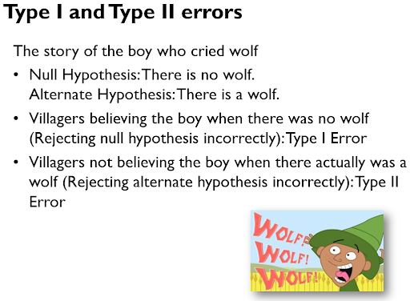
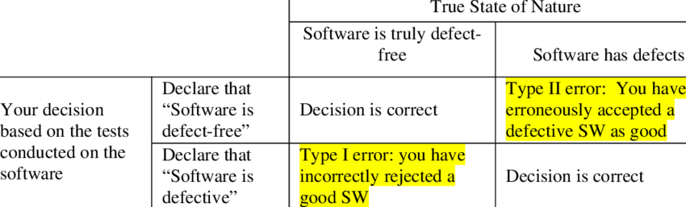

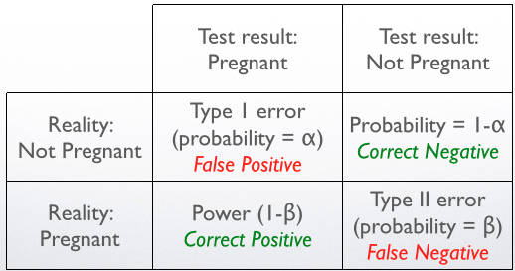

Tailed tests
One tailed test: - A test of a statistical hypothesis , where the region of rejection is on only one side of the sampling distribution , is called a one-tailed test.
If your alternative hypothesis uses >,>= or <,<= sign .
Example :- a college has ≥ 4000 student or data science ≤ 80% org adopted.

Two-tailed test: - A two-tailed test is a statistical test in which the critical area of a distribution is two-sided and tests whether a sample is greater than or less than a certain range of values. If the sample being tested falls into either of the critical areas, the alternative hypothesis is accepted instead of the null hypothesis.
If your alternative hypothesis uses = or ≠sign
Example : a college ≠ 4000 student or data science = 80% org adopted
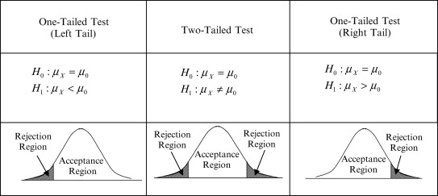

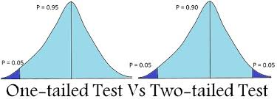

Hypothesis testing types
- T Test ( Student T test)
- Z Test
- ANOVA Test(F Test)
- Chi-Square Test

T- Test :- A t-test is a type of inferential statistic which is used to determine if there is a significant difference between the means of two groups which may be related in certain features. It is mostly used when the data sets, like the set of data recorded as outcome from flipping a coin a 100 times, would follow a normal distribution and may have unknown variances. T test is used as a hypothesis testing tool, which allows testing of an assumption applicable to a population.

T-test has 2 types :
1. one sampled t-test
2. two-sampled t-test.

One sample T-test : The One Sample t Test determines whether the sample mean is statistically different from a known or hypothesized population mean. The One Sample t Test is a parametric test.

One Sample T Test Example
Sample question: your company wants to improve sales. Past sales data indicate that the average sale was $100 per transaction. After training your sales force, recent sales data (taken from a sample of 25 salesmen) indicates an average sale of $130, with a standard deviation of $15. Did the training work? Test your hypothesis at a 5% alpha level.
Step 1: H₀: μ = $100.
Step 2: H₁: μ > $100.
Step 3:
- The sample mean(x̄). This is given in the question as $130.
- The population mean(μ). Given as $100 (from past data).
- The sample standard deviation(s) = $15.
- Number of observations(n) = 25.
Step 4: Insert the items from above into the t score formula.
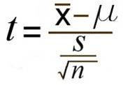
t = (130 – 100) / ((15 / √(25))
t = (30 / 3) = 10
This is your calculated t-value.
Step 5: Find the t-table value. You need two values to find this:
- The alpha level: given as 5% in the question.
- The degrees of freedom, which is the number of items in the sample (n) minus 1: 25 – 1 = 24.
Look up 24 degrees of freedom in the left column and 0.05 in the top row. The intersection is 1.711.This is your one-tailed critical t-value.
What this critical value means is that we would expect most values to fall under 1.711. If our calculated t-value (from Step 4) falls within this range, the null hypothesis is likely true.
Step 5: Compare Step 4 to Step 5. The value from Step 4 does not fall into the range calculated in Step 5, so we can reject the null hypothesis. The value of 10 falls into the rejection region (the left tail).
Example :- you have 10 ages and you are checking whether avg age is 30 or not.

fromscipy.stats import ttest_1samp
import numpy as np
ages = np.genfromtxt(“ages.csv”)
print(ages)
ages_mean = np.mean(ages)
print(ages_mean)
tset, pval = ttest_1samp(ages, 30)
print(“p-values”,pval)
ifpval< 0.05: # alpha value is 0.05 or 5%
print(" we are rejecting null hypothesis")
else:
print("we are accepting null hypothesis")

