Two sampled T-test:-The Independent Samples t Test or 2-sample t-test compares the means of two independent groups in order to determine whether there is statistical evidence that the associated population means are significantly different. The Independent Samples t Test is a parametric test. This test is also known as: Independent t Test.

A two-sample t-test is used to test the difference (d₀) between two population means. A common application is to determine whether the means are equal.
- Define hypotheses. The table below shows three sets of null and alternative hypotheses. Each makes a statement about the difference d between the mean of one population μ₁ and the mean of another population μ₂.
Set | Null hypothesis | Alternative hypothesis | Number of tails
1 | μ₁ - μ₂ = d | μ₁ - μ₂ ≠ d | 2
2 | μ₁ - μ₂ > d | μ₁ - μ₂ < d | 1
3 | μ₁ - μ₂ < d | μ₁ - μ₂ > d | 1
- Specify significance level. Often, researchers choose significance levels equal to 0.01, 0.05, or 0.10; but any value between 0 and 1 can be used.
- Find degrees of freedom. The degrees of freedom (DF) is:
DF = (s₁²/n₁ + s₂²/n₂)² / { [ (s₁² / n₁)² / (n₁ - 1) ] + [ (s₂² / n₂)² / (n₂ - 1) ] }
If DF does not compute to an integer, round it off to the nearest whole number.
Some texts suggest that the degrees of freedom can be approximated by the smaller of n₁ - 1 and n₂ - 1; but the above formula gives better results.
- Compute test statistic. The test statistic is a t statistic (t) defined by the following equation.
t = [ (x₁ - x₂) - d ] / sqrt[(s₁²/n₁) + (s₂²/n₂)]
where x₁ is the mean of sample 1, x₂ is the mean of sample 2, d is the hypothesized difference between population means, s₁ is the standard deviation of sample 1, s₂ is the standard deviation of sample 2, and n₁ is the size of sample 1, and n₂ is the size of sample 2.
- Compute P-value. The P-value is the probability of observing a sample statistic as extreme as the test statistic. Since the test statistic is a t statistic, use the t Distribution Calculator to assess the probability associated with the t statistic, having the degrees of freedom computed above.
- Evaluate null hypothesis. The evaluation involves comparing the P-value to the significance level , and rejecting the null hypothesis when the P-value is less than the significance level.
The two-sample t-test can be used when the population variances are equal or unequal, and with large or small samples.
Example : is there any association between week1 and week2
from scipy.stats import ttest_ind
import numpy as npweek1 = np.genfromtxt("week1.csv", delimiter=",")
week2 = np.genfromtxt("week2.csv", delimiter=",")print(week1)
print("week2 data :-\n")
print(week2)
week1_mean = np.mean(week1)
week2_mean = np.mean(week2)
print("week1 mean value:",week1_mean)
print("week2 mean value:",week2_mean)
week1_std = np.std(week1)
week2_std = np.std(week2)
print("week1 std value:",week1_std)
print("week2 std value:",week2_std)
ttest,pval = ttest_ind(week1,week2)
print("p-value",pval)
if pval <0.05:
print("we reject null hypothesis")
else:
print("we accept null hypothesis")

2-sampled t-test output
Paired sampled t-test :- The paired sample t-test is also called dependent sample t-test. It’s an uni variate test that tests for a significant difference between 2 related variables. An example of this is if you were to collect the blood pressure for an individual before and after some treatment, condition, or time point.

H0 :- means difference between two sample is 0
H1:- mean difference between two sample is not 0

import pandas as pd
from scipy import stats
df = pd.read_csv("blood_pressure.csv")
df[['bp_before','bp_after']].describe()
ttest,pval = stats.ttest_rel(df['bp_before'], df['bp_after'])
print(pval)
if pval<0.05:
print("reject null hypothesis")
else:
print("accept null hypothesis")

When you can run a Z Test.
Several different types of tests are used in statistics (i.e. f test, chi square test, t test). You would use a Z test if:
- Your sample size is greater than 30. Otherwise, use a t test.
- Data points should be independent from each other. In other words, one data point isn’t related or doesn’t affect another data point.
- Your data should be normally distributed. However, for large sample sizes (over 30) this doesn’t always matter.
- Your data should be randomly selected from a population, where each item has an equal chance of being selected.
- Sample sizes should be equal if at all possible.

One-Sample z-Test
A one-sample z-test is used to test whether a population parameter is significantly different from some hypothesized value.
- Define hypotheses. The table below shows three sets of null and alternative hypotheses. Each makes a statement about how the true population mean μ is related to some hypothesized value M. (In the table, the symbol ≠ means " not equal to ".)
Set | Null hypothesis | Alternative hypothesis | Number of tails
1 | μ = M | μ ≠ M | 2
2 | μ > M | μ < M | 1
3 | μ < M | μ > M | 1
- Specify significance level. Often, researchers choose significance levels equal to 0.01, 0.05, or 0.10; but any value between 0 and 1 can be used.
- Compute test statistic. The test statistic is a z-score (z) defined by the following equation.
z = (x - M ) / [ σ /sqrt(n) ]
where x is the observed sample mean, M is the hypothesized population mean (from the null hypothesis), and σ is the standard deviation of the population
- Compute P-value. The P-value is the probability of observing a sample statistic as extreme as the test statistic. Since the test statistic is a z-score, use the Normal Distribution Calculator to assess the probability associated with the z-score.
Evaluate null hypothesis. The evaluation involves comparing the P-value to the significance level, and rejecting the null hypothesis when the P-value is less than the significance level.

Note:- The one-sample z-test can be used when the population is normally distributed, and the population variance is known.
Example again we are using z-test for blood pressure with some mean like 156
one-sample Z test.

Example
Boys of a certain age are known to have a mean weight of μ = 85 pounds. A complaint is made that the boys living in a municipal children's home are underfed. As one bit of evidence, n = 25 boys (of the same age) are weighed and found to have a mean weight of x¯ = 80.94 pounds. It is known that the population standard deviation σ is 11.6 pounds (the unrealistic part of this example!). Based on the available data, what should be concluded concerning the complaint?

Solution. The null hypothesis is H₀: μ = 85, and the alternative hypothesis is H_{A}: μ < 85. In general, we know that if the weights are normally distributed, then:
follows the standard normal N(0,1) distribution. It is actually a bit irrelevant here whether or not the weights are normally distributed, because the same size n = 25 is large enough for the Central Limit Theorem to apply. In that case, we know that Z, as defined above, follows at least approximately the standard normal distribution. At any rate, it seems reasonable to use the test statistic:
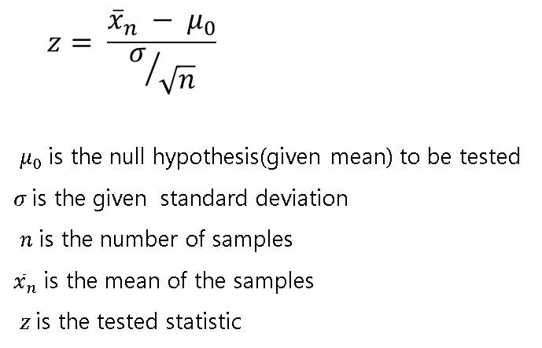

for testing the null hypothesis
H0:μ=μ0
against any of the possible alternative hypotheses HA:μ≠μ0, HA:μ<μ0, and HA:μ>μ0.
For the example in hand, the value of the test statistic is:
Z=80.94−8511.6/25−−√=−1.75
The critical region approach tells us to reject the null hypothesis at the α = 0.05 level if Z < −1.645. Therefore, we reject the null hypothesis because Z = −1.75 < −1.645, and therefore falls in the rejection region:
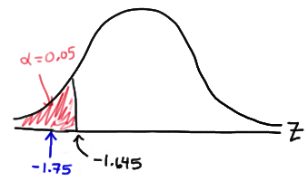
As always, we draw the same conclusion by using the P-value approach. Recall that the P-value approach tells us to reject the null hypothesis at the α = 0.05 level if the P-value ≤ α = 0.05. In this case, the P-value is P(Z < −1.75) = 0.0401:
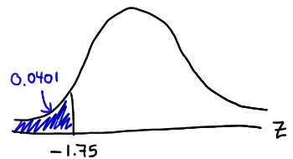
As expected, we reject the null hypothesis because the P-value = 0.0401 < α = 0.05.
By the way, we'll learn how to ask Minitab to conduct the Z-test for a mean μ in a bit, but this is what the Minitab output for this example looks like this:
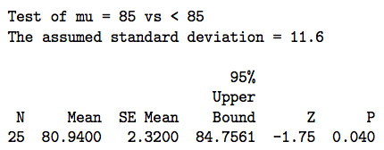

import pandas as pd
from scipy import stats
from statsmodels.stats
import weightstats as stests
ztest,pval = stests.ztest(df['bp_before'], x2=None, value=156)
print(float(pval))
if pval<0.05:
print("reject null hypothesis")
else:
print("accept null hypothesis")

z-Test for Proportions, Two Samples
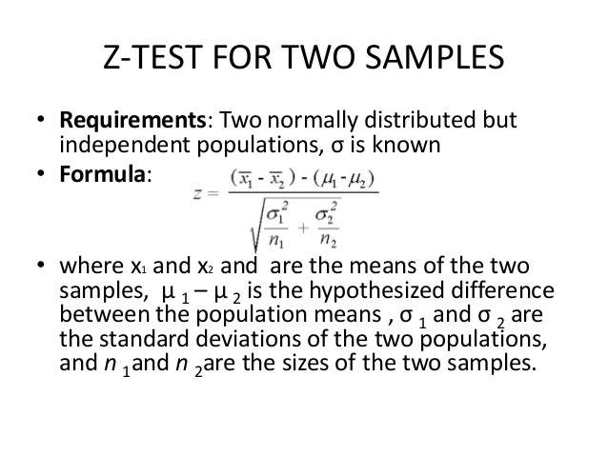
Let's perform a z-test for proportions, two samples: Researchers want to test the effectiveness of a new anti-anxiety medication. In clinical testing, 64 out of 200 people taking the medication report symptoms of anxiety. Of the people receiving a placebo, 92 out of 200 report symptoms of anxiety. Is the medication working any differently than the placebo? Test this claim using alpha = 0.05.
Steps for z-Test for Proportions, Two Samples
1. Define Null and Alternative Hypotheses
2. State Alpha
3. State Decision Rule
4. Calculate Test Statistic
5. State Results
6. State Conclusion
Let's begin.
1. Define Null and Alternative Hypotheses
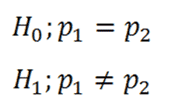
Figure 1.
2. State Alpha
Alpha = 0.05
3. State Decision Rule
Using an alpha of 0.05 with a two-tailed test, we would expect our distribution to look something like this:
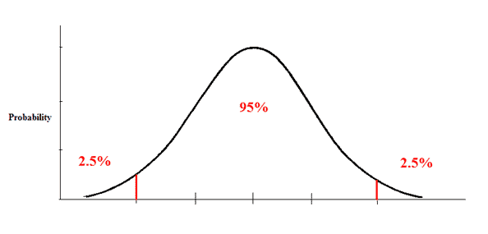
Figure 2.
Here we have 0.025 in each tail. Looking up 1 - 0.025 in our z-table, we find a critical value of 1.96. Thus, our decision rule for this two-tailed test is:
If Z is less than -1.96, or greater than 1.96, reject the null hypothesis.
4. Calculate Test Statistic
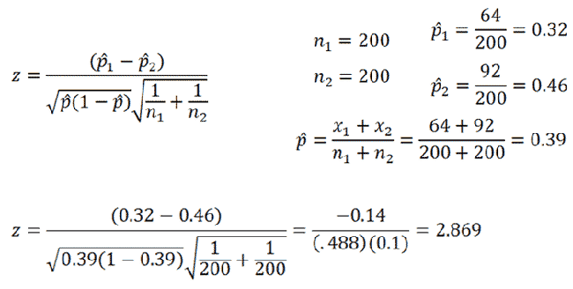
Figure 3.
5. State Results
z = 2.869
Result: Reject the null hypothesis.
6. State Conclusion
There was a significant difference in effectiveness between the medication group and the placebo group, z = -2.869, p < 0.05.
H₀ : mean of two group is 0
H₁ : mean of two group is not 0
Example : we are checking in blood data after blood and before blood data
ztest ,pval1 = stests.ztest(df['bp_before'], x2=df['bp_after'], value=0,alternative='two-sided')
print(float(pval1))
if pval<0.05:
print("reject null hypothesis")
else:
print("accept null hypothesis")

F Test or The Variance Ratio Test Compare Two Variances
- Objective of F Test is to find out whether the two independent estimates of the population variances differ significantly or whether two samples may be regarded as drawn from the normal populations having same variance
- For carrying out the Test of Significance we calculate the ratio F
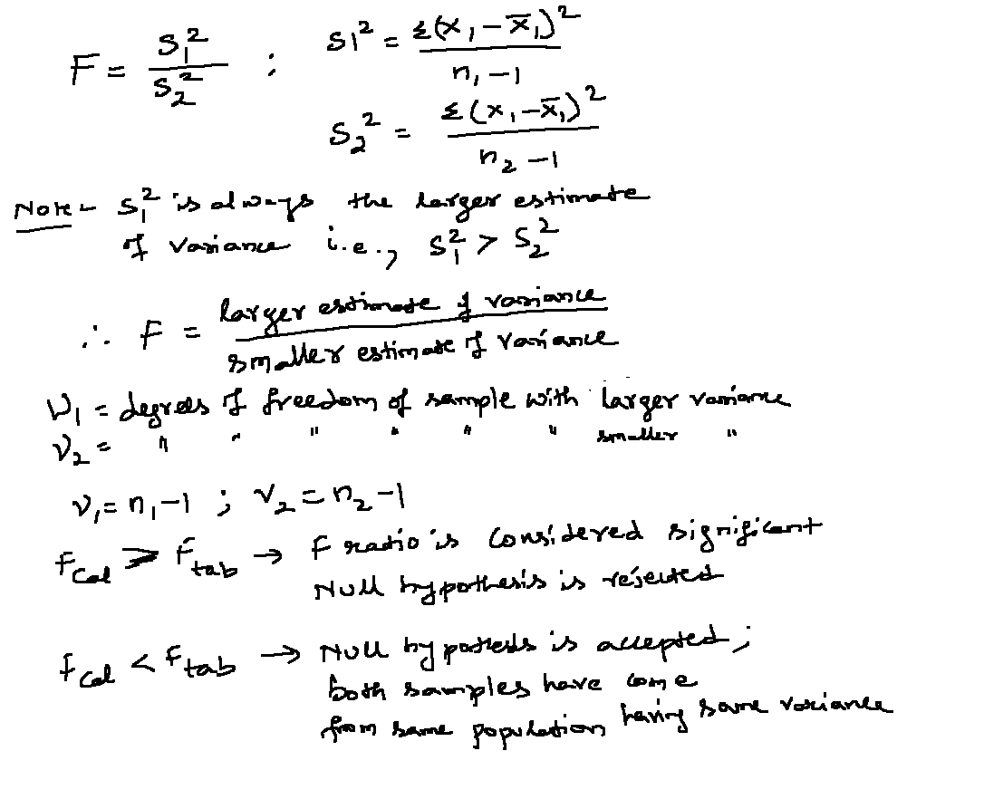

Assumptions
- Normality: Values in each group are normally distributed
- Homogenity : Variances should be equal
- Independence of Error : Errors should be independent for each value

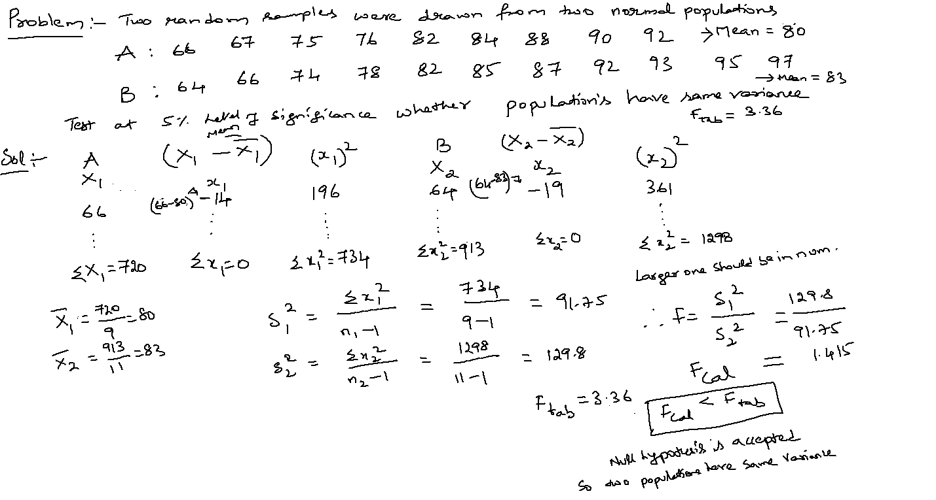

Two Tailed F-Test
The difference between running a one or two tailed F test is that the alpha level needs to be halved for two tailed F tests.
For example, instead of working at α = 0.05, you use α = 0.025;
instead of working at α = 0.01, you use α = 0.005.
With a two tailed F test, you just want to know if the variances are not equal to each other.
In notation:
H₀ : σ²₁ = σ² ₂
H₁ : σ²₁ ≠ σ² ₂

Sample problem: Conduct a two tailed F Test on the following samples:
Sample 1: Variance = 109.63, sample size = 41.
Sample 2: Variance = 65.99, sample size = 21.
Step 1: Write your hypothesis statements:
H_{o}: No difference in variances.
H₁: Difference in variances.
Step 2: Calculate your F critical value. Put the highest variance as the numerator and the lowest variance as the denominator:
F Statistic = variance 1/ variance 2 = 109.63 / 65.99 = 1.66
Step 3: Calculate the degrees of freedom:
The degrees of freedom in the table will be the sample size -1, so:
Sample 1 has 40 df (the numerator).
Sample 2 has 20 df (the denominator).
Step 4: Choose an alpha level. No alpha was stated in the question, so use 0.05. This needs to be halved for the two-tailed test, so use 0.025.
Step 5: Find the critical F Value using the F Table. There are several tables, so make sure you look in the alpha = .025 table. Critical F (40,20) at alpha (0.025) = 2.287.
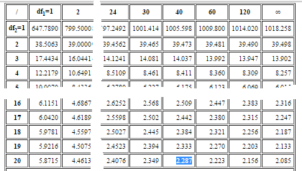
Step 6: Compare your calculated value (Step 2) to your table value (Step 5). If your calculated value is higher than the table value, you can reject the null hypothesis:
F calculated value: 1.66
F value from table: 2.287.
1.66 < 2 .287.
So we cannot reject the null hypothesis.

http://www.socr.ucla.edu/Applets.dir/F_Table.html

